CAPSTONE PROJECT REPORT
ML-Based Thermal Risk Prediction
in a Multi-Sensor Thermal System
From imperfect incubator telemetry to a validated local prediction API
Author | Fady Alami
Course | GSG-PSSAR Advanced Training
Model version | 1.0
Date | August 2026
Implemented scope: data validation, time-aware features, multi-horizon risk classification, model evaluation, saved pipelines, and local API. Closed-loop control remains future work.

Executive summary
Final outcome: The completed workflow retained 53,061 of 53,075 raw records, built leakage-safe 5/10/15-minute risk targets, selected a tuned Random Forest, evaluated it once on normalized held-out HATCH sequences, saved three pipelines, and exposed them through a local FastAPI service.

The capstone addresses an applied engineering problem: how to turn noisy multi-sensor incubator logs into early warnings that are useful before the temperature has already moved outside its operating band. The implemented output is predictive support, not automatic control.
The evidence supports the core design decisions. Data retention is 99.9736%; explicit ERR flags explain 99.59% of missing sensor readings; the reconstructed sampling interval is stable around 16.35 seconds; all five leakage/reproducibility checks pass; and the selected Random Forest has the highest validation balanced accuracy at every horizon.
The strongest held-out performance occurs at 5 and 10 minutes, where balanced accuracy is 0.650 and 0.648 and macro F1 is 0.639 for both. Performance declines at 15 minutes, and HIGH recall remains moderate. These limitations are reported directly because the project prioritizes an honest early-warning assessment over a single attractive accuracy number.

Document roadmap
- Sections 1-3 define the system, data, and leakage-safe analytical design.
- Sections 4-7 document data quality, features, targets, modeling, and evaluation.
- Sections 8-10 explain deployment, evidence for assumptions, and the debugging history.
- Sections 11-13 state limitations, improvements, reproducibility steps, and the final conclusion.

1. Project objective, scope, and success criteria

1.1 Engineering objective
The incubator produces time-stamped messages containing four sensor readings and controller state. The project objective is to predict whether the average temperature will become LOW, stay NORMAL, or become HIGH over the next 5, 10, and 15 minutes. The forecast uses the current state and recent thermal behavior so it can act as an early-warning layer rather than a delayed alarm.

1.2 Implemented scope
- Row-preserving raw-data loading, structural validation, parsing, and reporting.
- Continuous-sequence reconstruction and separate sensor/controller quality audits.
- Current features, historical means, humidity-fan fractions, and temperature slopes.
- Mode-aware, multi-horizon thermal-risk targets with explicit ambiguity handling.
- Chronological sequence splits, three candidate model families, tuning, and one held-out test.
- Three saved preprocessing-and-model pipelines plus a local FastAPI service.
- Final analytical tables and 11 plots supporting the main assumptions.

1.3 Explicit exclusion
Scope boundary: Disturbance-aware closed-loop control was not implemented. The model can provide a prediction to a future controller, but no automatic actuator command is produced in this version.

1.4 Success criteria
- Preserve traceability and report all exclusions.
- Prevent past features and future targets from crossing recording discontinuities.
- Prevent future information and test sequences from entering training.
- Evaluate minority risks using balanced accuracy, macro F1, and class-specific recall.
- Save complete pipelines so inference repeats the training preprocessing exactly.
- Expose a simple, testable local API and document remaining limitations.

2. Physical data and end-to-end workflow

2.1 Available signals
Each telemetry record combines four temperature/humidity sensors with flags (`A`, `P`, or `ERR`), controller averages, heater duty, duty correction, instantaneous heater/fan states, servo position, operating mode, sensor spread, active-sensor count, rotation information, and edge counters. The raw message is expected to contain 17 pipe-separated sections.

2.2 Workflow
Stage | Purpose | Primary output
1 | Preserve, validate, parse | incubator_prepared.csv
2 | Sequences, quality, history, future averages | stage2 master + ML table
3 | Slopes and LOW/NORMAL/HIGH targets | incubator_stage3_targets.csv
4 | Chronological comparison and held-out test | stage4 reports
5 | Train and save final pipelines | three joblib models + metadata
6 | Serve predictions locally | FastAPI /health and /predict
7 | Consolidate evidence | tables, plots, report bundle
Source: project-generated reports in final_analysis_bundle.zip.
The stages are deliberately separate. Each output becomes a documented interface to the next stage, which improves repeatability and makes it possible to diagnose problems without rerunning or modifying later steps.

3. Stage 1 - raw-data preparation and validation

3.1 Row-preserving loader
The first difficulty was that a conventional CSV load could fail or shift a row when a telemetry message contained an extra comma. The loader therefore reads physical records with Python's CSV reader, preserves the first field as the timestamp, rejoins all remaining fields as the raw message, and records the original source line and field count. Structural validation happens only after preservation.

3.2 Parsing rules
- Require the CSV header `timestamp,message`.
- Support both timestamp formats observed in the log.
- Check the expected 17 message sections.
- Preserve acquisition order with `record_id`.
- Retain structurally valid rows with `ERR`; keep unavailable values missing.
- Report incomplete records before excluding them.
Measure | Value
Raw physical rows | 53,075
Structurally complete | 53,061
Rejected | 14
Retention | 99.9736%
Prepared columns | 27
Source: project-generated reports in final_analysis_bundle.zip.

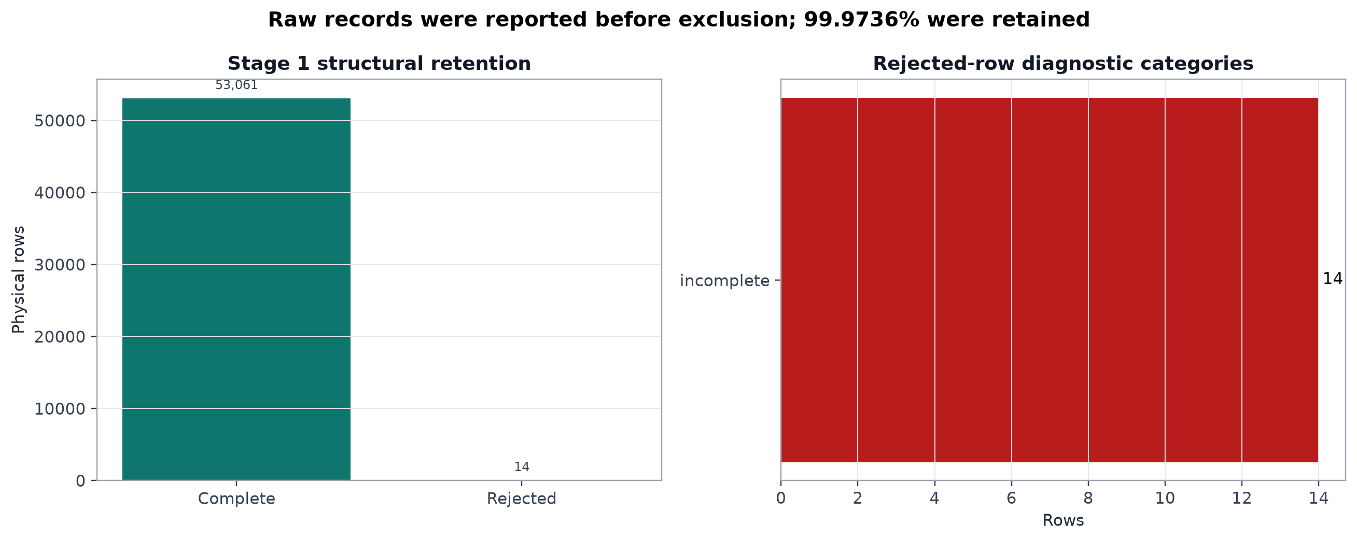
Figure 1. Stage 1 structural retention and rejected-row diagnostics.
Interpretation. Only 0.0264% of physical rows are excluded. The plot supports the decision to report structural failures without allowing a handful of malformed messages to disturb the valid acquisition order. Source: project-generated analytical evidence.

4. Stage 2 - sequences, quality, and time-aware features

4.1 Continuous-sequence reconstruction
A new sequence begins at the dataset start, a backward timestamp, or a gap greater than three minutes. This threshold tolerates short operational interruptions while preventing history and targets from crossing long pauses. Two backward timestamps create single-row sequences; they are preserved for traceability and naturally contribute no complete history/target windows.
Sequence | Start reason | Rows | Duration (min) | Interval (s)
1 | Dataset start | 534 | 146 | 16.435
2 | Gap > 3 min | 4,445 | 1,210 | 16.337
3 | Gap > 3 min | 13,948 | 3,796 | 16.330
4 | Backward time | 1 | 0 | -
5 | Gap > 3 min | 9,762 | 2,655 | 16.320
6 | Backward time | 1 | 0 | -
7 | Gap > 3 min | 19,944 | 5,438 | 16.361
8 | Gap > 3 min | 2,669 | 727 | 16.349
9 | Gap > 3 min | 1,757 | 479 | 16.367
Source: project-generated reports in final_analysis_bundle.zip.

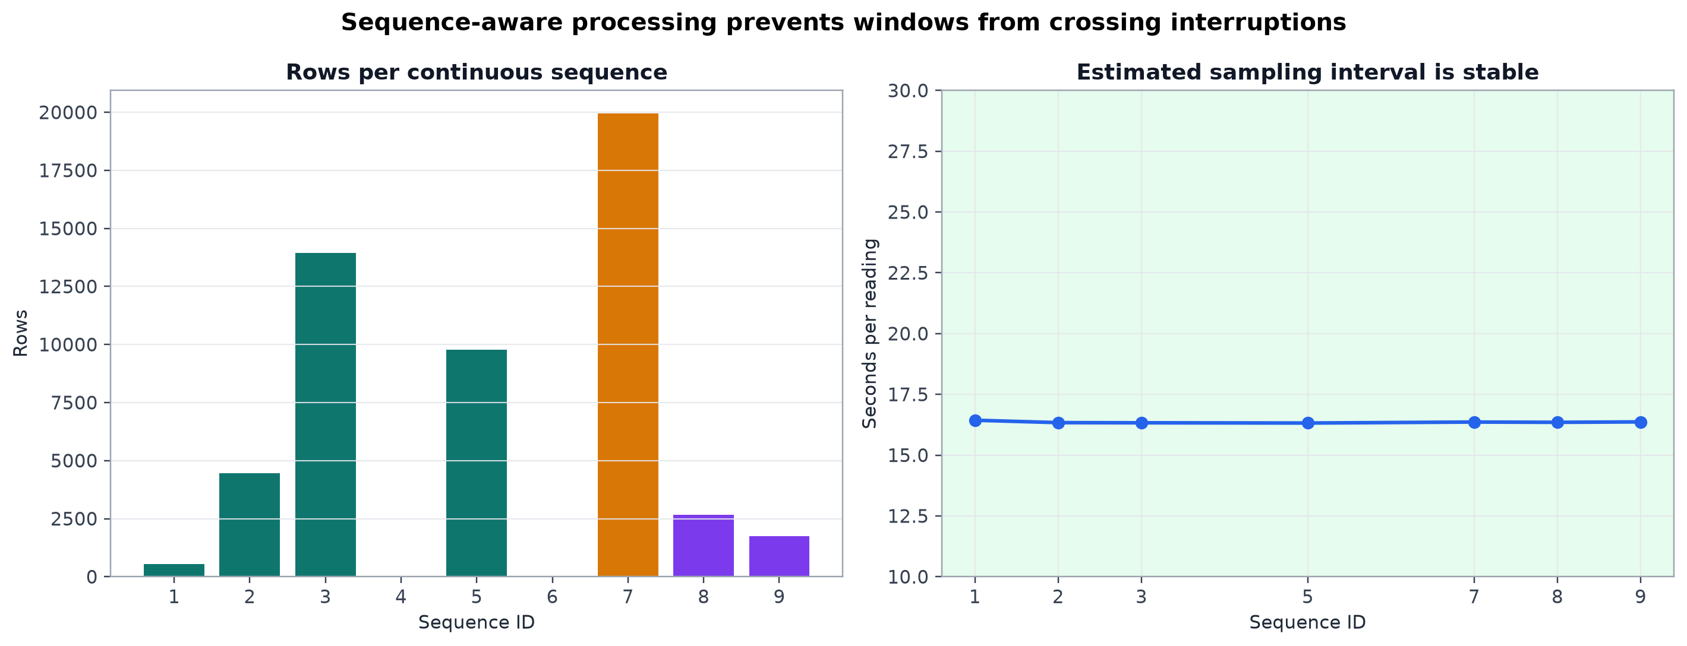
Figure 2. Sequence sizes and estimated sampling intervals.
Interpretation. Sequence sizes vary strongly, but the estimable sampling interval is stable within a narrow 16.32-16.44 second range. Time-based windows are therefore meaningful when calculated separately inside each sequence. Source: project-generated analytical evidence.

4.2 Sensor and controller quality
Sensor missingness is separated into explicit errors, unexpected missing values, invalid flags, and implausible values. This avoids treating a known device state as if it were random data loss. There are 1,462 missing sensor readings; 1,456 are explained by explicit `ERR` flags. Only nine rows contain unexpected sensor-quality issues.
Sensor | Missing | Explicit ERR | Unexpected | Invalid flags | Implausible
S1 | 155 | 153 | 2 | 2 | 3
S2 | 103 | 102 | 1 | 1 | 1
S3 | 1,201 | 1,199 | 2 | 2 | 0
S4 | 3 | 2 | 1 | 1 | 0
Source: project-generated reports in final_analysis_bundle.zip.

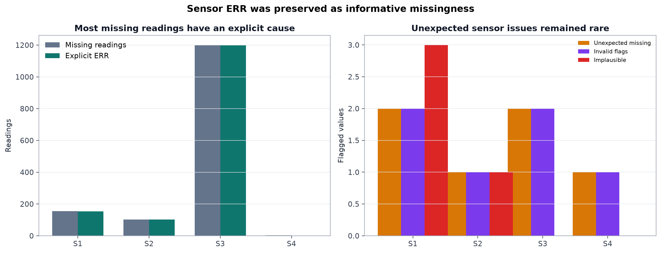
Figure 3. Sensor missingness and unexpected-quality evidence.
Interpretation. Sensor 3 contributes most missing values, but nearly all are explicitly explained. Preserving the flags and deferring numerical imputation to the saved model pipeline is therefore more defensible than silently filling values during preparation. Source: project-generated analytical evidence.
Controller checks found only isolated issues: two for average humidity, one for duty percentage, one for duty correction, one for humidity-fan state, two for servo position, and one for the low-edge counter. These records were reported rather than silently rewritten.

4.3 Feature design
The primary current signals are `s2_t`, `s3_t`, and `duty_pct`: the active temperatures and commanded heater effort. Supporting context includes all sensor temperatures/humidities, duty correction, averages, sensor spread, humidity-fan state, and operating mode. Historical means and fan fractions are computed over the previous 5, 10, and 15 minutes.
Important exclusion: `heater_on` was excluded because the approximately 16-second logging interval is too slow to represent short PWM pulses reliably. `duty_pct` is a more faithful description of commanded heater activity at this resolution.

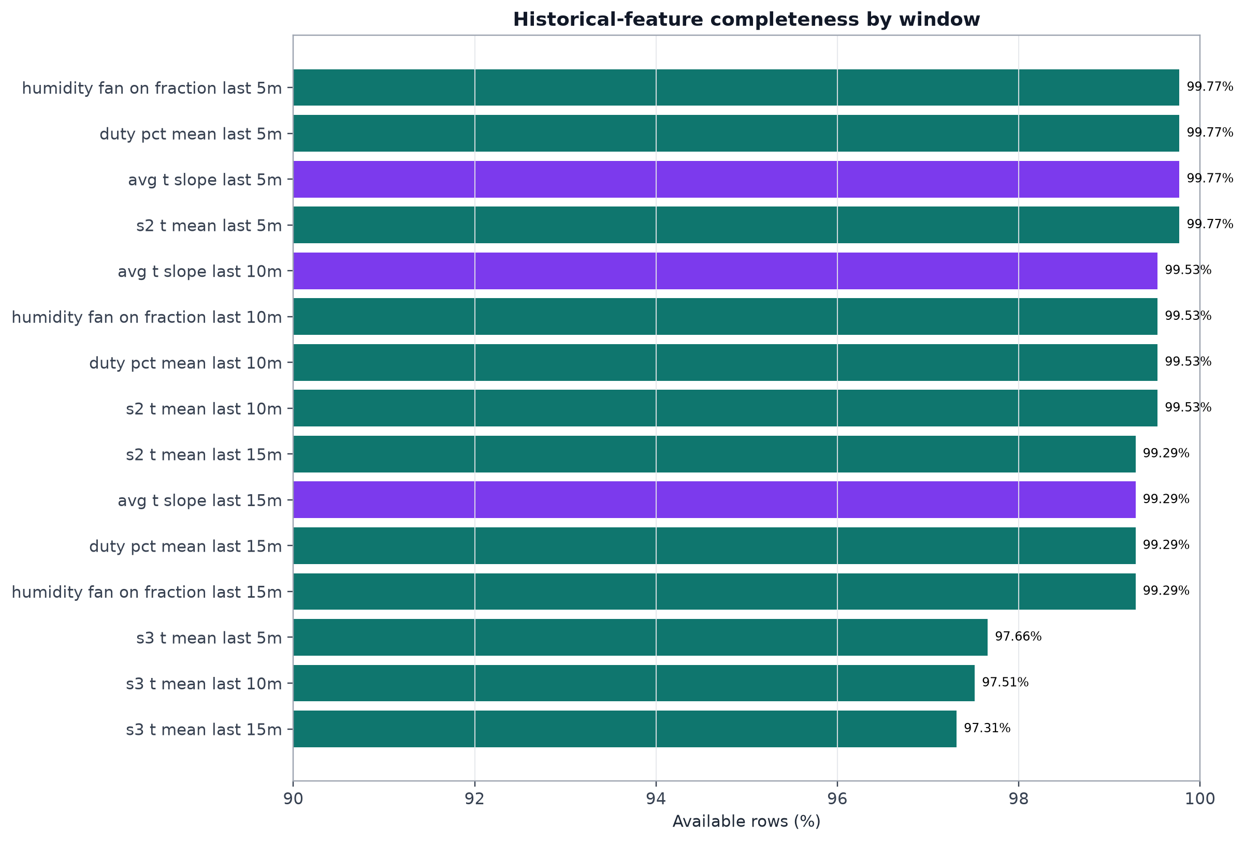
Figure 4. Availability of history and slope features.
Interpretation. Missing history grows with the window length and is concentrated at sequence starts. Lower availability for sensor 3 histories is consistent with its explicit ERR events. This pattern is expected and confirms that past windows are not being fabricated across sequence boundaries. Source: project-generated analytical evidence.

5. Stage 3 - risk targets and slope features

5.1 Target definition
For each row, the complete future window is examined. Its minimum and maximum average temperature determine risk. NRML mode uses a 37.3-37.7 °C normal band; HTCH mode uses 37.1-37.5 °C. A window crossing both limits is ambiguous and excluded from that target rather than being assigned an arbitrary class.
Horizon | LOW | NORMAL | HIGH | Available | Ambiguous
5 min | 2,884 | 48,962 | 1,053 | 52,899 | 13
10 min | 4,290 | 46,642 | 1,715 | 52,647 | 118
15 min | 5,558 | 44,502 | 2,270 | 52,330 | 290
Source: project-generated reports in final_analysis_bundle.zip.

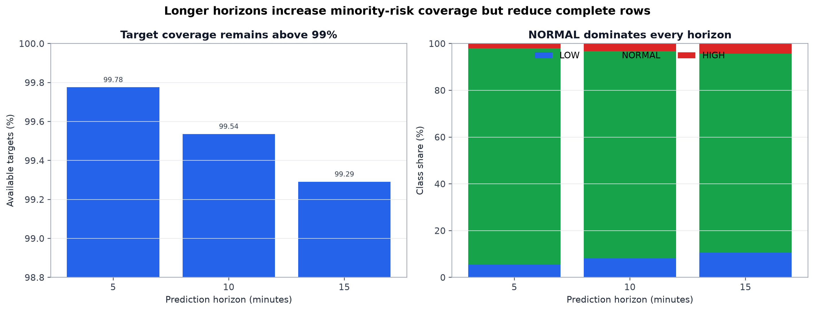
Figure 5. Target availability and class balance by horizon.
Interpretation. Target availability stays above 99% at every horizon. NORMAL nevertheless dominates, from 92.56% at 5 minutes to 85.04% at 15 minutes. This is direct evidence that raw accuracy alone would be misleading. Source: project-generated analytical evidence.

5.2 Temperature slopes
A linear slope is fitted to `avg_t` over each past window using elapsed minutes. It summarizes thermal direction and speed while remaining sequence-aware. For future HIGH cases, median slopes are positive at all horizons (approximately 0.0057, 0.0058, and 0.0039 °C/min). LOW and NORMAL medians are close to zero, although class distributions overlap.

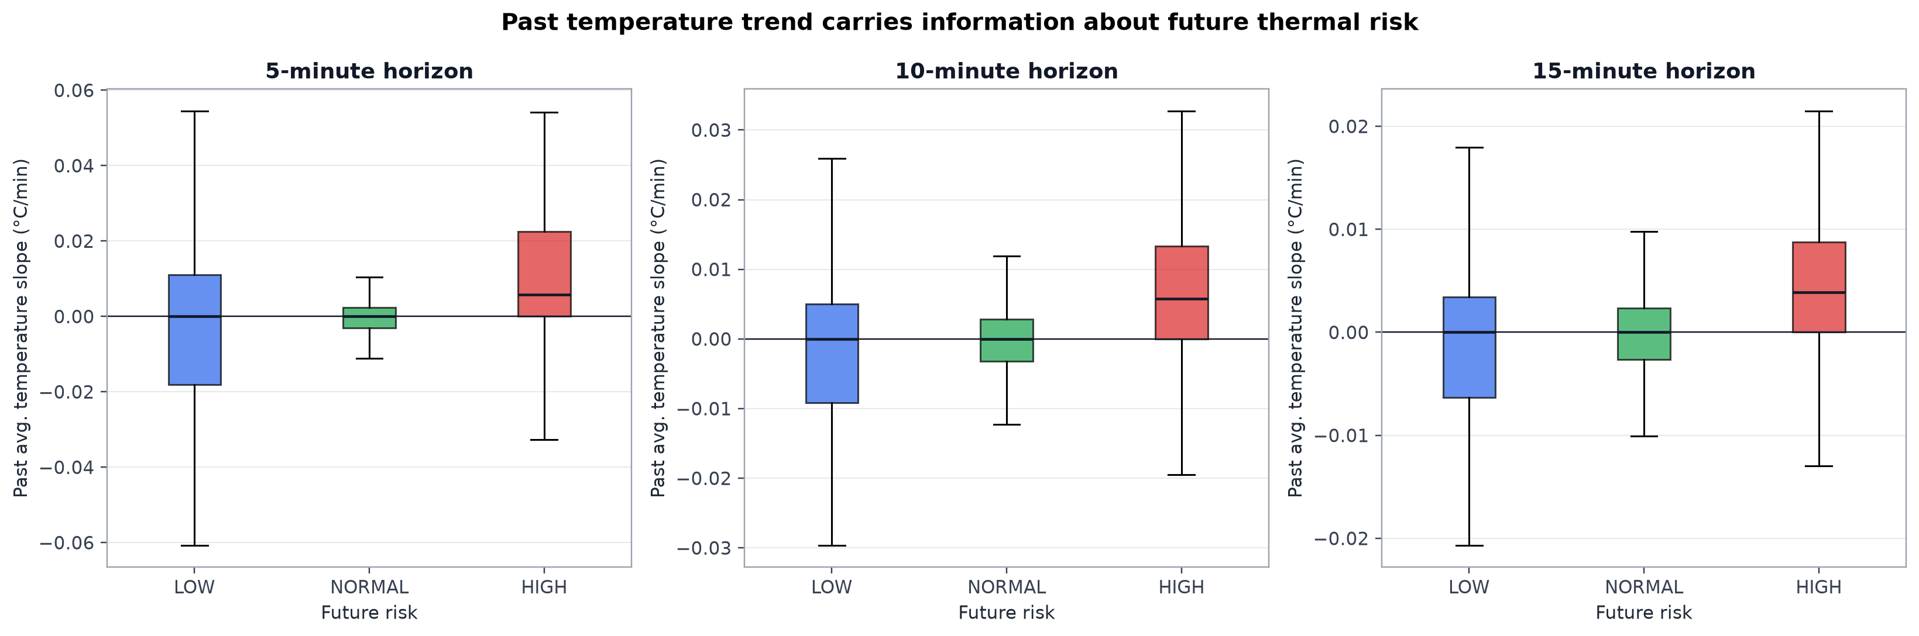
Figure 6. Past temperature slope grouped by future risk.
Interpretation. HIGH-risk windows tend to have more positive recent slopes, especially at shorter horizons. The overlap shows that slope is useful context but not a standalone rule. The plot supports predictive association, not causation. Source: project-generated analytical evidence.

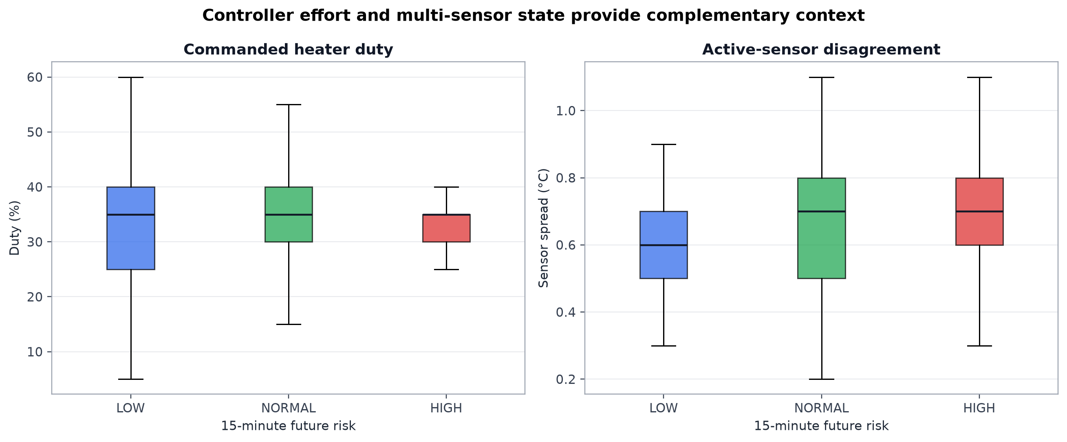
Figure 7. Duty effort and sensor spread by 15-minute future risk.
Interpretation. LOW cases show higher commanded duty on average, while HIGH cases show lower duty and somewhat larger sensor spread. These relationships support including controller effort and multi-sensor disagreement alongside temperature history. Source: project-generated analytical evidence.

6. Stage 4 - modeling strategy

6.1 Chronological split and leakage prevention
After dropping rows without all three risk targets, 52,330 usable rows remain. The split uses complete sequences rather than random rows: Train contains sequences 1/2/3/5, Validation contains sequence 7, and Test contains sequences 8/9. Neighboring points from the same physical run can therefore never appear on both sides of a split.
Split | Sequences | Rows | Role
Train | 1, 2, 3, 5 | 28,264 | Fit candidates
Validation | 7 | 19,759 | Tune/select
Test | 8, 9 | 4,307 | One final evaluation
Source: project-generated reports in final_analysis_bundle.zip.

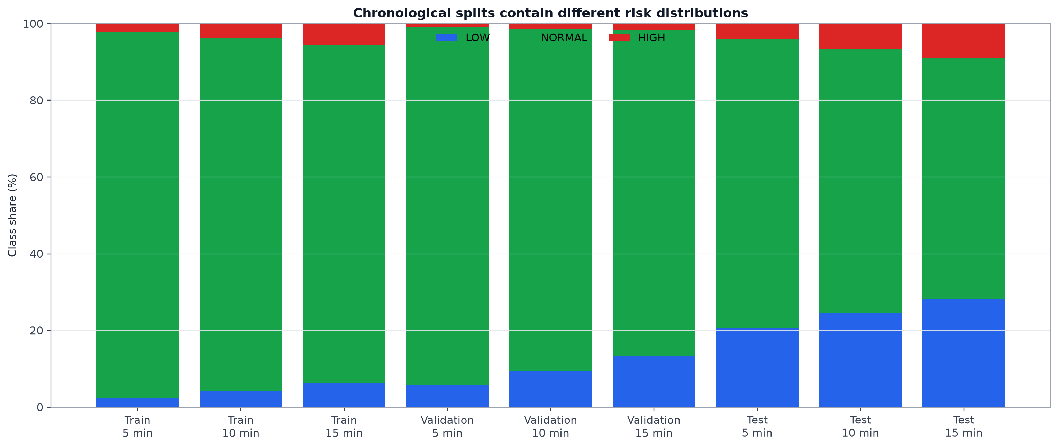
Figure 8. Risk-class distribution across chronological splits.
Interpretation. The distribution changes across Train, Validation, and HATCH-only Test sequences. Balanced metrics and class-specific recall are necessary because a model can appear accurate simply by following the local NORMAL majority. Source: project-generated analytical evidence.

6.2 Candidate models and metrics
Model | Role | Key treatment
Logistic Regression | Linear baseline | Scaling + balanced class weights
Random Forest | Nonlinear ensemble | Depth/leaf constraints + balanced weights
XGBoost | Boosted-tree comparator | Depth + early best iteration
Source: project-generated reports in final_analysis_bundle.zip.
Balanced accuracy is the primary selection metric because it averages recall across all classes. Macro F1 gives each class equal weight in the harmonic mean of precision and recall. Accuracy remains useful for context but is not sufficient for selection.

6.3 Tuning and model selection
Initial flexible tree configurations could fit training patterns much better than chronological validation behavior. The final Random Forest is intentionally constrained to depth 6, with minimum leaf sizes 20/20/10 at 5/10/15 minutes and 200 trees. The fixed random seed is 42.
Model | 5m BA | 10m BA | 15m BA | Decision
Logistic Regression | 0.580 | 0.587 | 0.594 | Baseline
Random Forest | 0.653 | 0.628 | 0.627 | Selected
XGBoost | 0.625 | 0.590 | 0.610 | Comparator
Source: project-generated reports in final_analysis_bundle.zip.

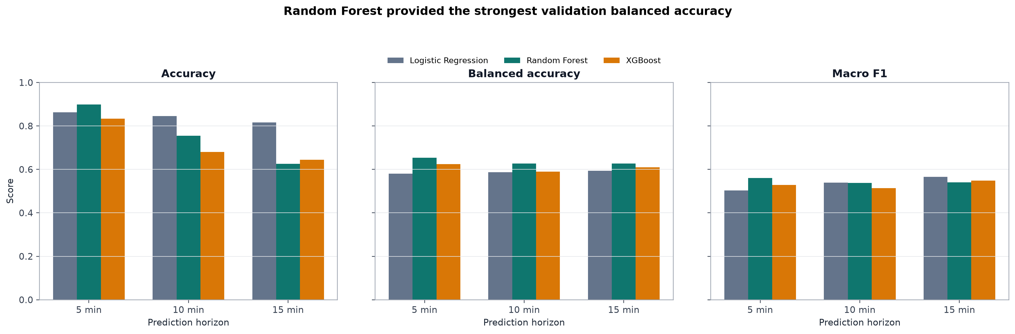
Figure 9. Validation comparison across model families and horizons.
Interpretation. Random Forest has the highest balanced accuracy at all three horizons. Logistic Regression retains higher raw accuracy at longer horizons but has very low LOW recall, illustrating why balanced accuracy drives selection. Source: project-generated analytical evidence.

7. HATCH normalization and final held-out evaluation

7.1 Why a coordinate translation was needed
The held-out sequences are entirely HTCH mode. Its normal band is centered at 37.3 °C, while NRML is centered at 37.5 °C. A +0.2 °C translation aligns absolute-temperature coordinates with the earlier reference. This is not relabeling: risk classes are mode-aware and remain unchanged.

7.2 Verification rules
- Apply exactly +0.2 °C to 14 absolute-temperature columns.
- Leave temperature slopes and sensor spread unchanged.
- Leave humidity, controller state, mode, identifiers, and targets unchanged.
- Write a separate normalized test file; never overwrite the Stage 3 source.

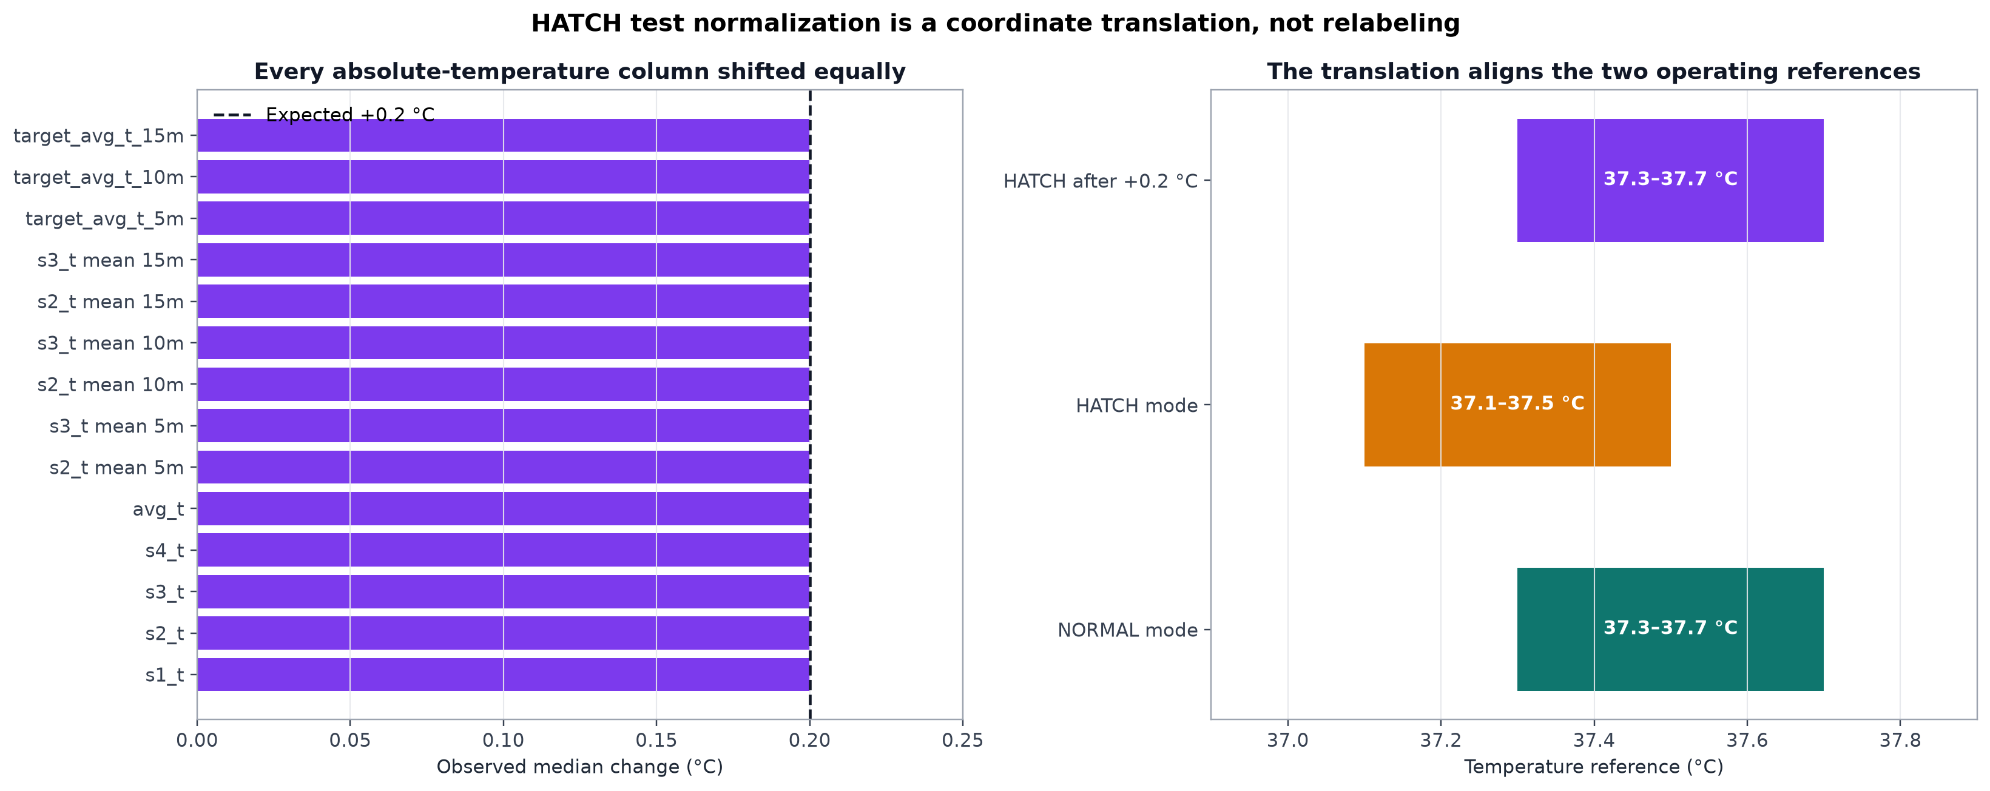
Figure 10. Verification of the HATCH coordinate translation.
Interpretation. Every tested absolute-temperature column changes by exactly +0.2 °C within floating-point tolerance. Protected columns have zero change. This supports the normalization as a coordinate translation rather than label manipulation. Source: project-generated analytical evidence.

7.3 Final test results
Horizon | Accuracy | Balanced acc. | Macro F1 | LOW recall | HIGH recall
5 min | 0.831 | 0.650 | 0.639 | 0.692 | 0.365
10 min | 0.766 | 0.648 | 0.639 | 0.641 | 0.465
15 min | 0.669 | 0.595 | 0.596 | 0.581 | 0.466
Source: project-generated reports in final_analysis_bundle.zip.

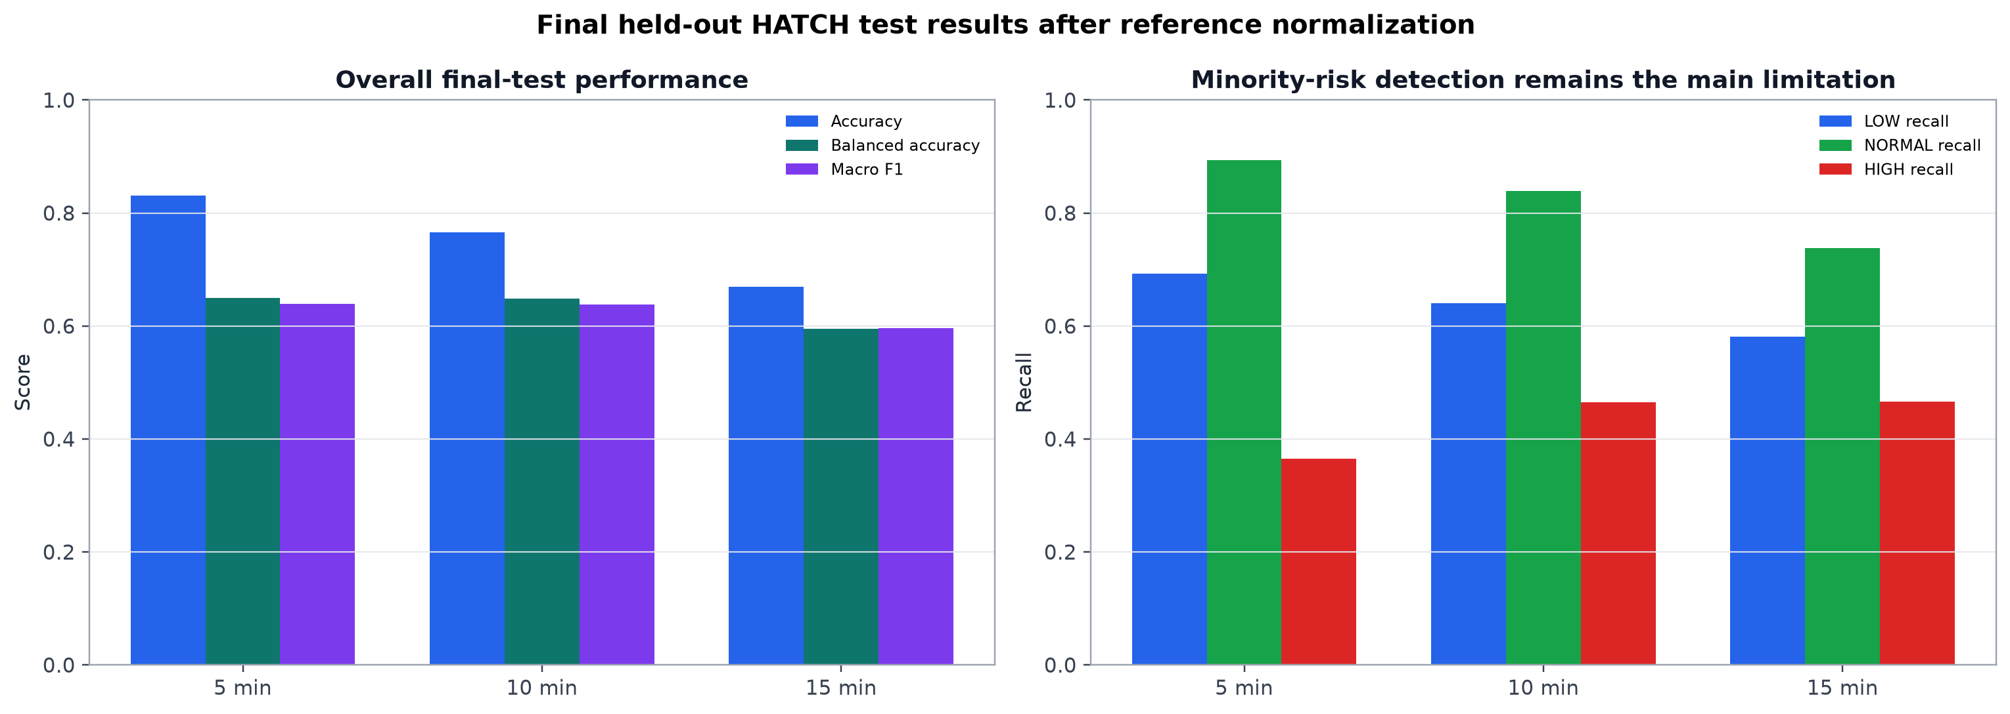
Figure 11. Final held-out HATCH performance.
Interpretation. The model provides useful overall discrimination, particularly at 5 and 10 minutes. Longer-horizon performance declines and HIGH detection remains moderate. These class-specific results define the correct operational limitation of version 1.0. Source: project-generated analytical evidence.

8. Stage 5 - saved models and local API

8.1 Deployment artifacts
The final Train + Validation sequences are used to fit three independent Random Forest pipelines. Test sequences are not read by the training script. Each pipeline contains numerical median imputation, categorical most-frequent imputation, one-hot encoding for `operating_mode`, and the classifier. This reduces training-serving mismatch because preprocessing is saved with the estimator.
Target | Artifact
temperature_risk_5m | random_forest_5m.joblib
temperature_risk_10m | random_forest_10m.joblib
temperature_risk_15m | random_forest_15m.joblib
Metadata | model_metadata.json
Held-out examples | api_test_examples.json
Source: project-generated reports in final_analysis_bundle.zip.

8.2 API behavior
FastAPI loads the metadata and all three saved pipelines when the service starts. `GET /health` confirms readiness, model type, version, model count, and feature count. `POST /predict` validates the exact 31-feature contract, restores the stored order and types, and returns one risk label for each horizon.
Endpoint | Method | Purpose
/health | GET | Confirm three models and metadata are ready
/predict | POST | Predict LOW/NORMAL/HIGH at 5/10/15 minutes
/docs | Browser | Interactive Swagger documentation
Source: project-generated reports in final_analysis_bundle.zip.
Interpretation: The API response is a model prediction, not a heater command. Raw live telemetry must first pass through Stage 1-3-equivalent preprocessing and feature engineering.

9. Evidence for the project assumptions
The following matrix connects each important design decision to measured evidence. It prevents the report from presenting engineering choices as unsupported opinions.
Decision | Measured evidence | Supported
Preserve raw rows before exclusion | 53,061 of 53,075 physical rows were structurally complete (99.9736% retention); rejected rows were reported. | True
Treat ERR as informative missingness | Explicit ERR explains 1,456 of 1,462 missing sensor readings (99.59%). | True
Reconstruct time within sequences | Estimable sequence intervals range from 16.32 to 16.44 seconds; nine sequences prevent cross-gap windows. | True
Use 5/10/15-minute future targets | Target availability is 5m=99.78%, 10m=99.54%, 15m=99.29%. | True
Use balanced metrics | NORMAL represents 5m=92.56%, 10m=88.59%, 15m=85.04%; accuracy therefore overstates minority-class performance. | True
Add historical temperature slopes | Median slope by 15-minute risk: LOW=-0.0000, NORMAL=-0.0000, HIGH=0.0039 °C/min. | True
Translate HATCH test temperatures by +0.2 °C | All 14 absolute-temperature columns changed by exactly +0.2 °C; slopes, spread, and labels remained unchanged. | True
Select tuned Random Forest | Validation balanced accuracy across 5/10/15 minutes was 0.653/0.628/0.627, the strongest model-wise result at each horizon. | True
Keep test data isolated | All 5 leakage/reproducibility checks passed; sequences 8 and 9 are absent from training and validation. | True
Report limitations, not accuracy alone | Final HIGH recall across 5/10/15 minutes is 0.365/0.465/0.466; minority-risk detection remains moderate. | True
Source: project-generated reports in final_analysis_bundle.zip.
The evidence is empirical and project-specific. In particular, plots linking slopes or controller effort to future classes show association in this dataset; they do not prove causal control relationships.

10. Development milestones, difficulties, and solutions
Difficulty | Diagnosis | Implemented solution
Malformed CSV record | Extra commas could break a normal loader or shift columns. | Row-wise CSV parsing, source-line preservation, and message reconstruction.
Mixed sensor missingness | Most missing measurements were explicit device errors. | Preserve ERR flags; impute numerics only inside model pipelines.
Interrupted time series | Rolling windows could cross real gaps or backward times. | Nine sequences; all history and future windows restricted by sequence.
Short PWM pulses | Logged heater_on snapshots were too coarse. | Use duty_pct; exclude heater_on from the model contract.
Severe class imbalance | Accuracy favored the dominant NORMAL class. | Balanced accuracy, macro F1, class weights, and risk recalls.
Tree overfitting | Flexible trees learned sequence-specific patterns. | Constrain depth/leaf size and select on chronological validation.
Operating-mode shift | Held-out HATCH reference was 0.2 °C lower. | Separate verified +0.2 °C coordinate translation on test only.
Inference consistency | A bare estimator would not enforce preprocessing/order. | Save full pipelines, metadata, exact validation, and real examples.
Source: project-generated reports in final_analysis_bundle.zip.

10.1 Milestone summary
- Validated raw acquisition and preserved traceability.
- Reconstructed time and generated quality evidence.
- Defined mode-aware future risk and slope features.
- Established chronological Train/Validation/Test sequences.
- Compared and tuned three model families.
- Normalized the HATCH test coordinate and evaluated once.
- Saved deployment pipelines and verified the local API.
- Generated a final evidence bundle, report, README, and presentation.

11. Limitations and responsible interpretation
- The dataset comes from one physical incubator and nine recorded sequences; external generalization is not demonstrated.
- The chronological splits have different class distributions and the test sequences are HATCH-only.
- Targets are derived from future average temperature, not independent biological hatch outcomes.
- HIGH recall is 0.365/0.465/0.466 at 5/10/15 minutes and remains the main model limitation.
- The API expects engineered features and is not yet connected directly to raw streaming telemetry.
- Only model version 1.0 is active; production version management and monitoring are not implemented.
- The service is verified locally; public cloud deployment is outside the current capstone need.
- No closed-loop actuator policy has been implemented or safety-validated.
Recommended use: Treat version 1.0 as a decision-support and demonstration system. Do not use it as an unsupervised hardware safety controller without additional data, calibration, real-time preprocessing, and bounded-control validation.

12. Improvements and future work
- Collect more LOW and HIGH events under both NRML and HTCH modes.
- Validate on another incubator or a later independent data period.
- Package Stage 1-3 logic as one online feature builder for raw telemetry.
- Tune class-specific decision thresholds or costs to improve HIGH recall.
- Calibrate class probabilities and return confidence alongside labels.
- Add version-management and monitoring endpoints if production requirements justify them.
- Monitor feature drift, class mix, and sensor ERR rates after deployment.
- Simulate any future disturbance-aware controller and enforce physical safety bounds before hardware integration.
Further tuning on the same held-out test sequences is not recommended. The next useful gain should come from new minority-risk data and independent validation, not repeated adaptation to the current test set.

13. Reproducibility guide

13.1 Execution order
- Place `incubator_bt_log2.csv` under `data/raw/`.
- Run `python p1.py`.
- Run `python p2.py`.
- Run `python p3.py`.
- Run `python prepare_stage4_normalized_test.py`.
- Run `python p4.py`.
- Run `python p5.py`.
- Run `python api_test_examples.py`.
- Run `python p6_final_analysis.py --project-root .`.
- Start the API with `uvicorn api:app --reload --host 127.0.0.1 --port 8000` and open `/docs`.

13.2 Recorded environment
Component | Version
Python | 3.13.3
numpy | 2.4.6
pandas | 3.0.3
matplotlib | 3.11.0
scikit-learn | 1.9.0
xgboost | 3.4.1
joblib | 1.5.3
fastapi | 0.141.1
uvicorn | 0.52.3
Source: project-generated reports in final_analysis_bundle.zip.

13.3 Reproducibility controls
- Stable input/output paths for each stage.
- Sequence-based splits stored in scripts and metadata.
- Random Forest random_state fixed at 42.
- Complete preprocessing embedded in each saved model pipeline.
- Ordered feature names and model files recorded in model_metadata.json.
- Source inventory includes sizes and SHA-256 hashes for analytical inputs.

14. Final conclusion
This capstone completes the requested machine-learning path from imperfect multi-sensor telemetry to an evidence-backed local prediction service. The project preserves raw traceability, avoids sequence leakage, uses time-aware and physically motivated features, evaluates three model families with balanced metrics, and reports both strengths and weaknesses of the selected Random Forest.
The final model is most useful as an early-warning demonstration at 5 and 10 minutes. Its 15-minute performance and moderate HIGH recall show where uncertainty grows. The work is therefore complete as a prediction-and-API capstone, while the path to a stronger operational system is clear: more minority-risk data, independent hardware validation, online feature construction, calibrated confidence, and safety-bounded controller testing.

Appendix A - final feature groups
Group | Included information
Current sensors | Four temperatures, four humidities, sensor flags
Controller state | avg_t, avg_h, duty_pct, duty correction, humidity fan
System context | sensor spread and operating mode
5-minute history | s2/s3 means, duty mean, fan fraction, avg_t slope
10-minute history | s2/s3 means, duty mean, fan fraction, avg_t slope
15-minute history | s2/s3 means, duty mean, fan fraction, avg_t slope
Source: project-generated reports in final_analysis_bundle.zip.
Identifiers, timestamps, future averages, target segment identifiers, and risk labels are explicitly excluded from model input.

Appendix B - selected slope statistics
15m risk | Count | Mean slope | Median slope | Q1 | Q3
LOW | 5449 | 0.00167 | -0.00000 | -0.00631 | 0.00341
NORMAL | 44288 | 0.00024 | -0.00000 | -0.00261 | 0.00234
HIGH | 2217 | 0.00703 | 0.00387 | -0.00000 | 0.00876
Source: project-generated reports in final_analysis_bundle.zip.
Units are °C per minute. The distributions overlap, so slope is combined with other current and historical features rather than used as a deterministic threshold.

